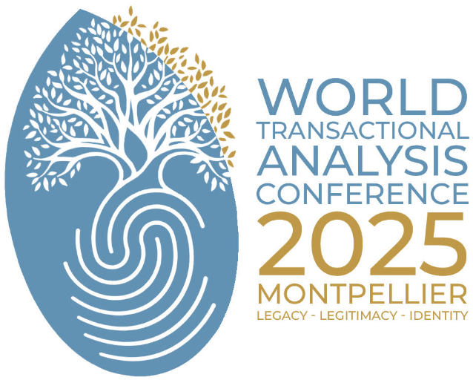
"Exploring Legacy, Legitimacy, and Identity: Transactional Analysis in a Changing World"

Please read all aspects of the contract carefully before submitting your responses.

Presenter’s name:
Title of presentation:
Telephone:
Email ID:

TA Affiliation:
☐ ITAA
☐ EATA
☐ IFAT
☐ Other affiliation (please state): ________________

TA Status:
☐ CTA
☐ CTA TRAINER
☐ PTSTA
☐ TSTA
☐ Regular Member (please add an endorsement signed by a P/TSTA)
☐ Trainee (please add an endorsement signed by a P/TSTA)
☐ No TA Status (please add an endorsement signed by a P/TSTA)

Field(s):
☐ COUNSELLING
☐ EDUCATIONAL
☐ ORGANISATIONAL
☐ PSYCHOTHERAPY

Co-presenter (if any, please indicate status and field):

Duration of the workshop:
Each workshop should last for either:
☐ 90 minutes (1h30),
or:
☐ 3 hours (please note that the number of 3h-workshop will be limited and not guaranteed)

Audience of the workshop:
Fields (s)
☐ COUNSELLING
☐ EDUCATIONAL
☐ ORGANISATIONAL
☐ PSYCHOTHERAPY
Level of the audience
☐ Beginner
☐ Advanced
☐ All

Language of the workshop:
I agree to submit my workshop proposal in English
For the workshops presenter, English is the preferred language; if not:
☐ I indicate the language to present my workshop: ____________
☐ I agree to bring an English translator under my own responsibility & cost.

Optional Workshop Room Arrangement / Equipment:
☐ projector (most of the workshop room will be equipped)
☐ white board (Flipchart markers should be available as well, however we recommend you carry your own markers)

Audio/Video recording (please check):
☐ I give permission for my presentation to be audio/video recorded.
☐ I do not give permission for my presentation to be audio/video recorded.

Conference Papers: (indicate your choice)
☐ I agree to submit a paper related to the theoretical content or background of my workshop for inclusion in the Conference Papers, which may be produced digitally and/or in paper for sale at the conference. I agree to send the material via e-mail.
☐ I will not submit a paper for publication.

Contract to Present (check all the items indicating your consent)
☐ I agree to attend the conference and make the presentation hereby enclosed.
☐ I understand that changing these commitments will disrupt the conference programme.
☐ I understand that I am completely responsible for my conference fee and all travel and attendance related expenses.

Liability Disclaimer: (check all the items indicating your consent)
☐ I hereby declare myself completely responsible for my travel and stay at the conference, and disclaim and free ITAA/EATA/IFAT from any liability related to these matters.
☐ I understand that I am fully responsible for the safety and protection of the participants of my presentation and that the organisers/ ITAA/EATA/IFAT are not liable in this matter.

Confidentiality of Ground Rules
FOR PROVIDING CONFIDENTIALITY AND PROTECTION TO PARTICIPANTS WHO ARE
WORKING IN GROUP EXPERIMENTAL SETTINGS
In order to avoid any violations of the protection that we strive to live and teach by, the Program Committee drafted the following list of rules for each presenter to review with participants.
Your signature:

